Poster Notes

Criteria:

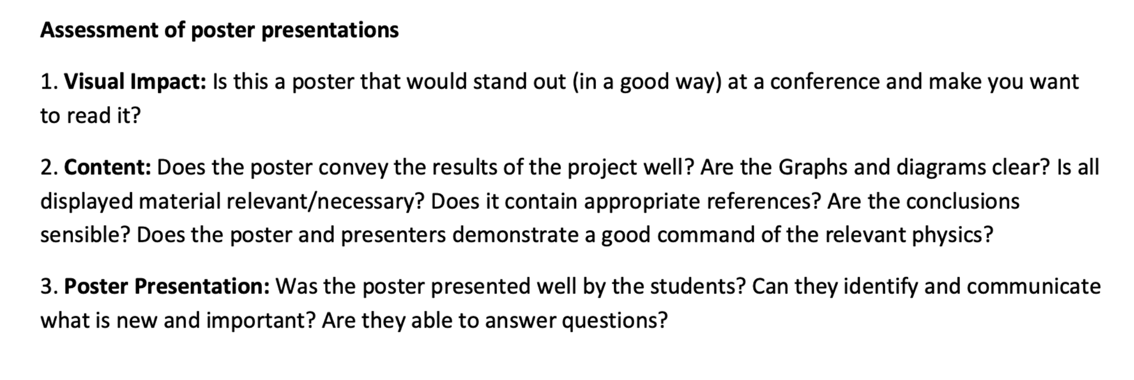

TODO:  
(1) Think what we will be asked

Is there anything we’ve included that they will catch us out on.

--> Honest about level of comparison -> mainly on stretcher however not others due to realistic material limitations (materials science complex and NOT simulation)

--> Will probably ask what other research is similar to this

It is applied to important problems, used for testing all sorts of biological things, like how stretchy RBCs are which can indicate sickle cell anemia. And, in the lab, for testing the material properties of biological structures of polymers like stretching DNA.

We demonstrate that it is valid to simulate a flexible particle in this way and currently have a good flexible model, but only uses a few simple components like spring and bending forces. In reality, as the material structure of things are researched, they could be implemented and quickly tested to see if it matches what is seen in the lab, so it is a way to test theoretical equations which model things - more complex than our current spring/bending.